String Functions

- Concat

Concatenate command is used to joins the letters.
CONCAT_WS command is used to insert special character between the letters.

CONCAT Cmd:
- SELECT CONCAT('pi', 'ckle');

- SELECT CONCAT(author_fname,' ', author_lname) AS author_name FROM books;

- CONCAT_WS Cmd:

- SELECT CONCAT_WS('-',title, author_fname, author_lname) FROM books;

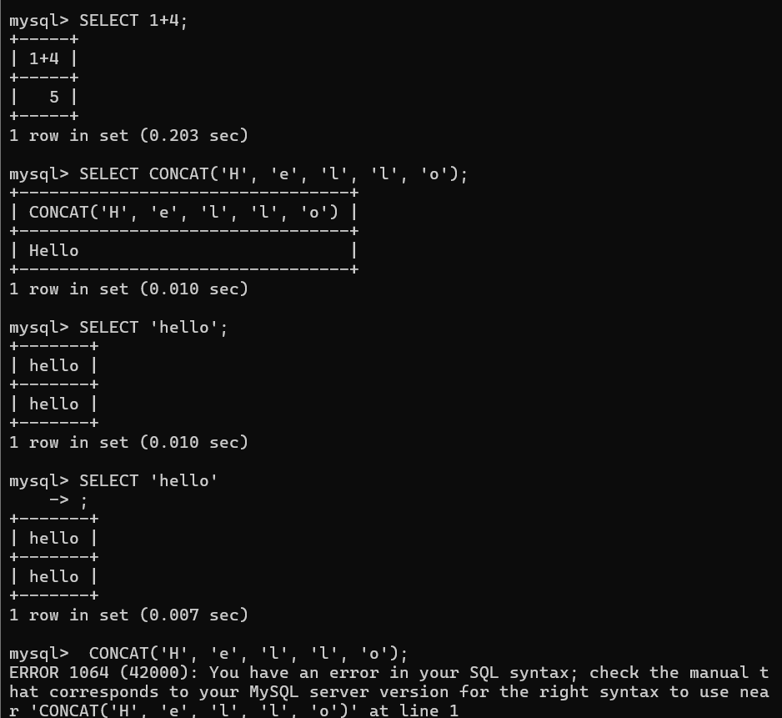

Concat cmd ss:

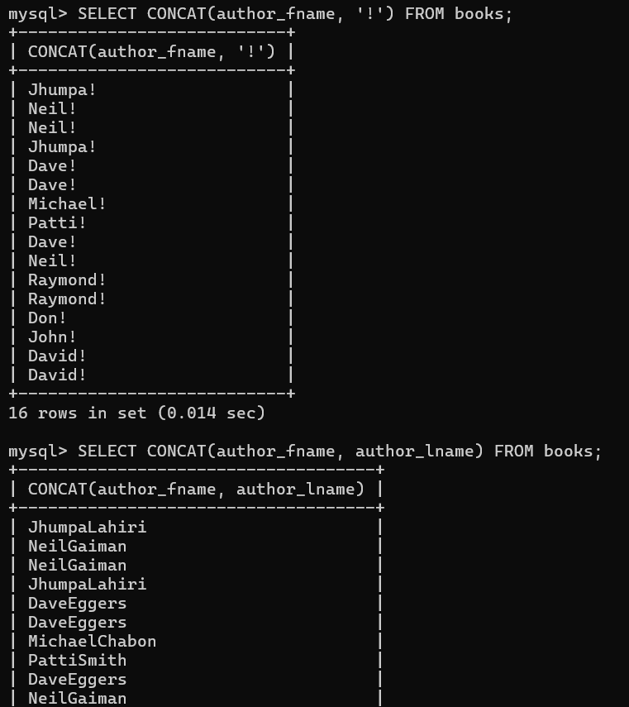

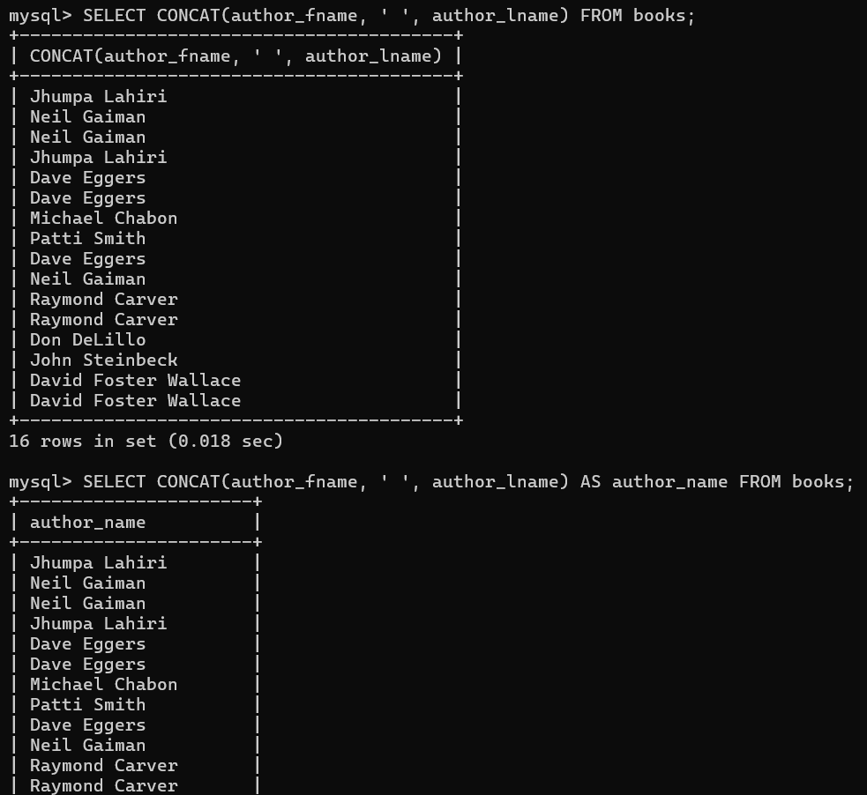

Concat_ws ss:

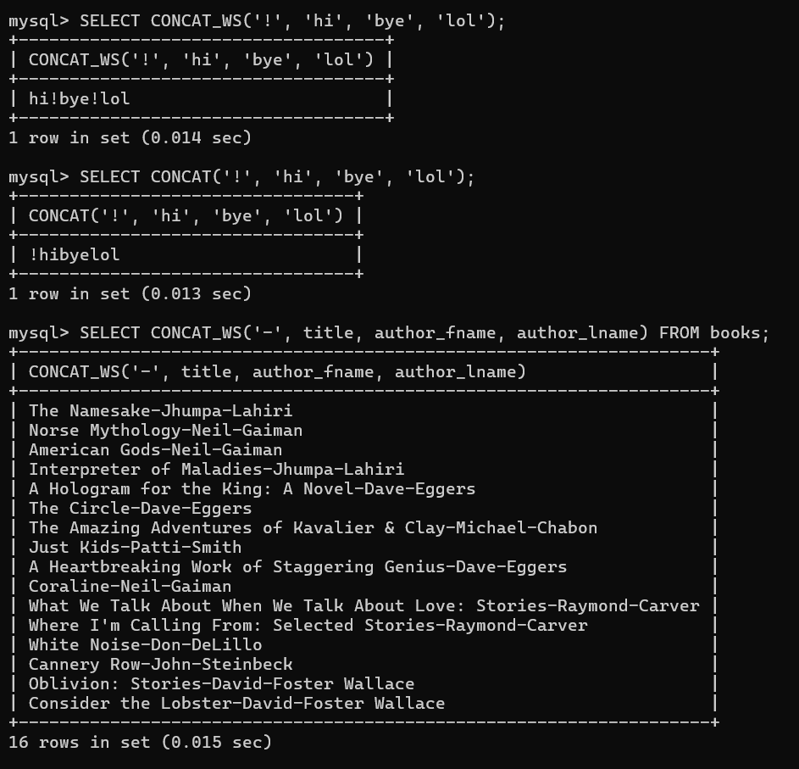

3. SUBSTRING

Substring format is used start from the letter and then length of the letter.

- SELECT SUBSTRING('Hello World', 1, 4);

- SELECT SUBSTRING('Hello World', 7);

- SELECT SUBSTRING('Hello World', -3);

- SELECT SUBSTRING(title, 1, 10) AS 'short title' FROM books;

- SELECT SUBSTR(title, 1, 10) AS 'short title' FROM books;

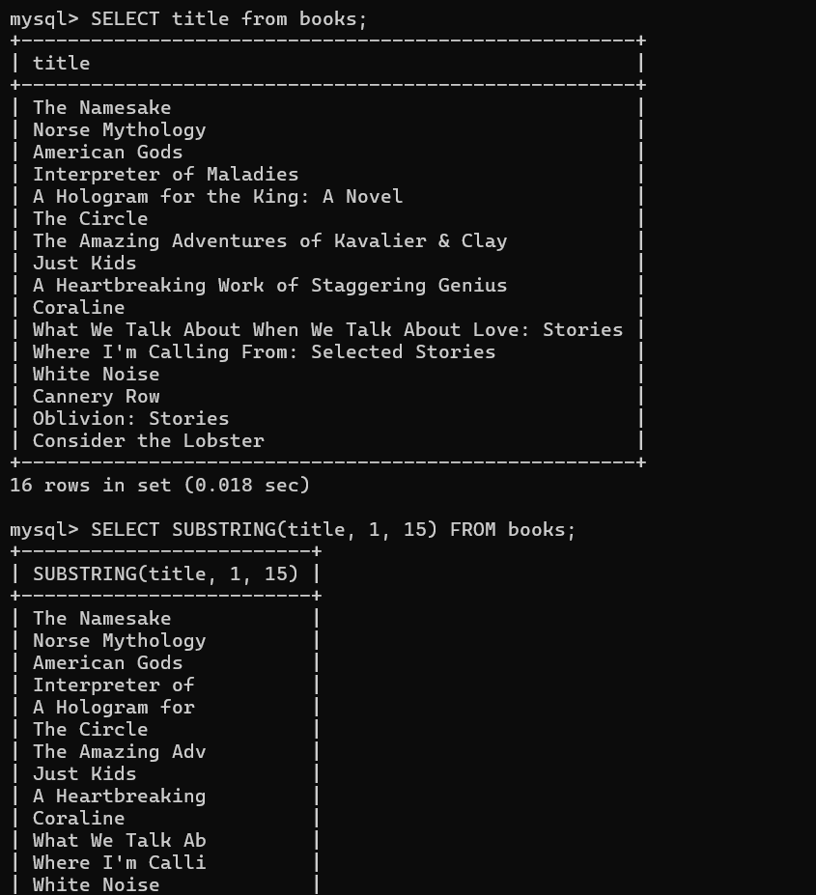

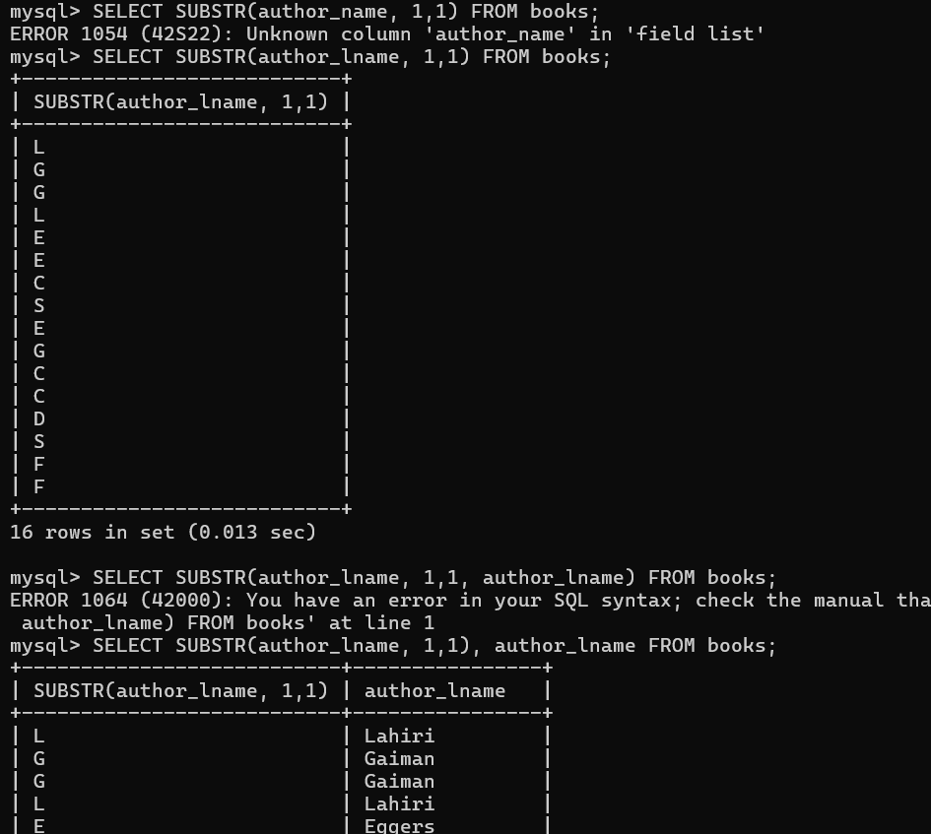

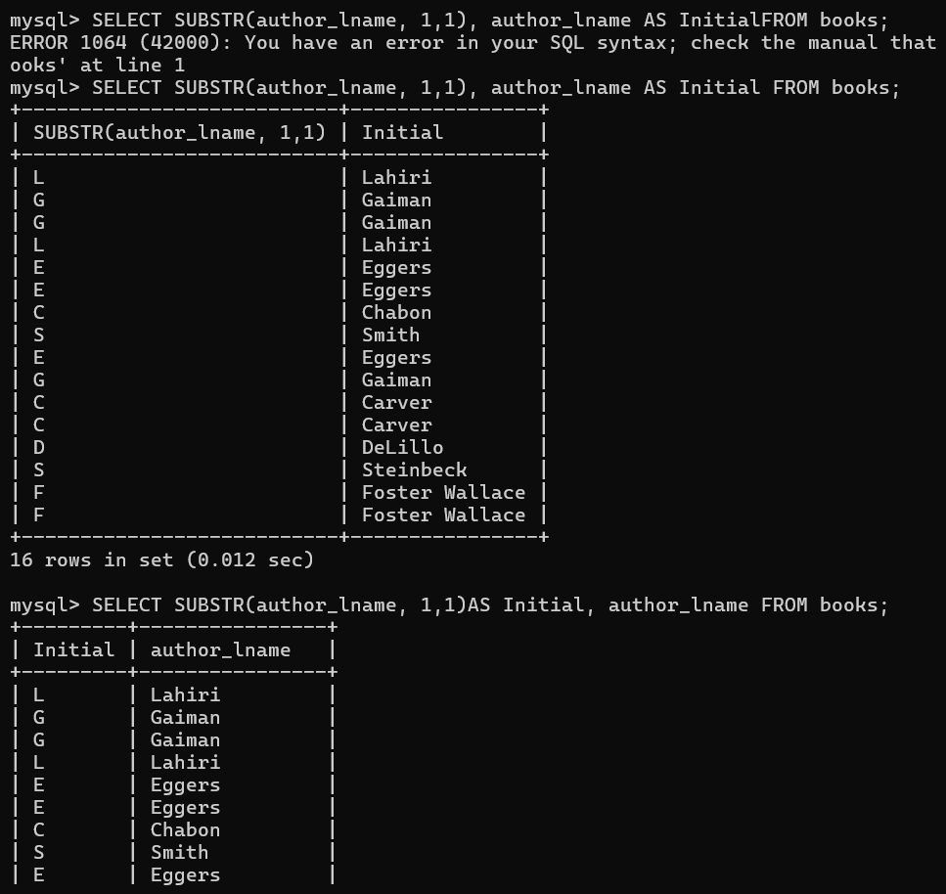

4. Combing String Functions:

Using SUBSTRING AND CONCAT function.

- SELECT CONCAT
- (
- SUBSTRING(title, 1, 10),
- '...'
- ) AS 'short title'
- FROM books;

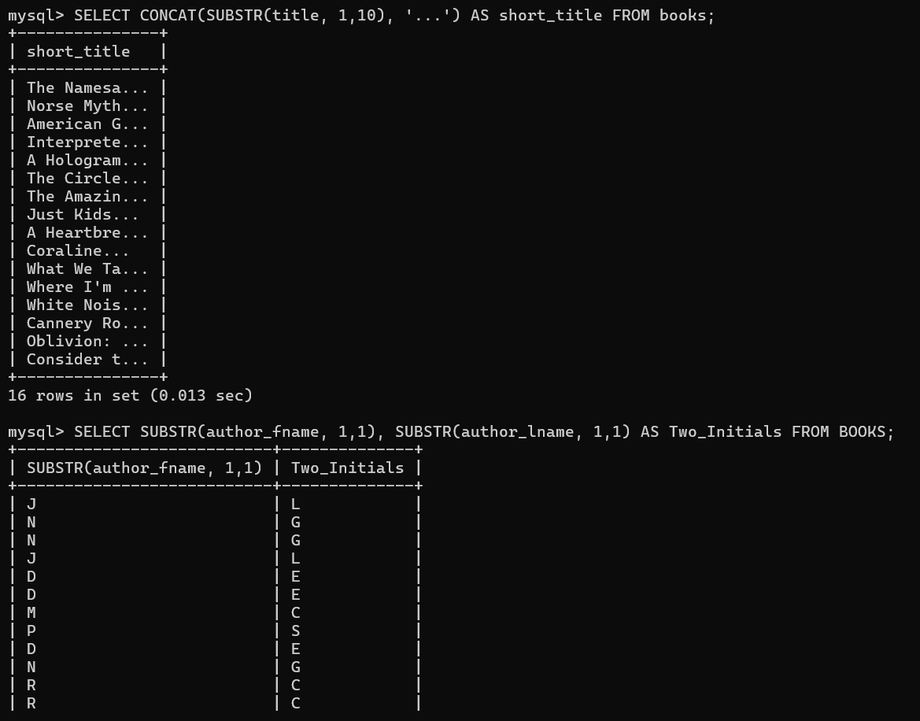

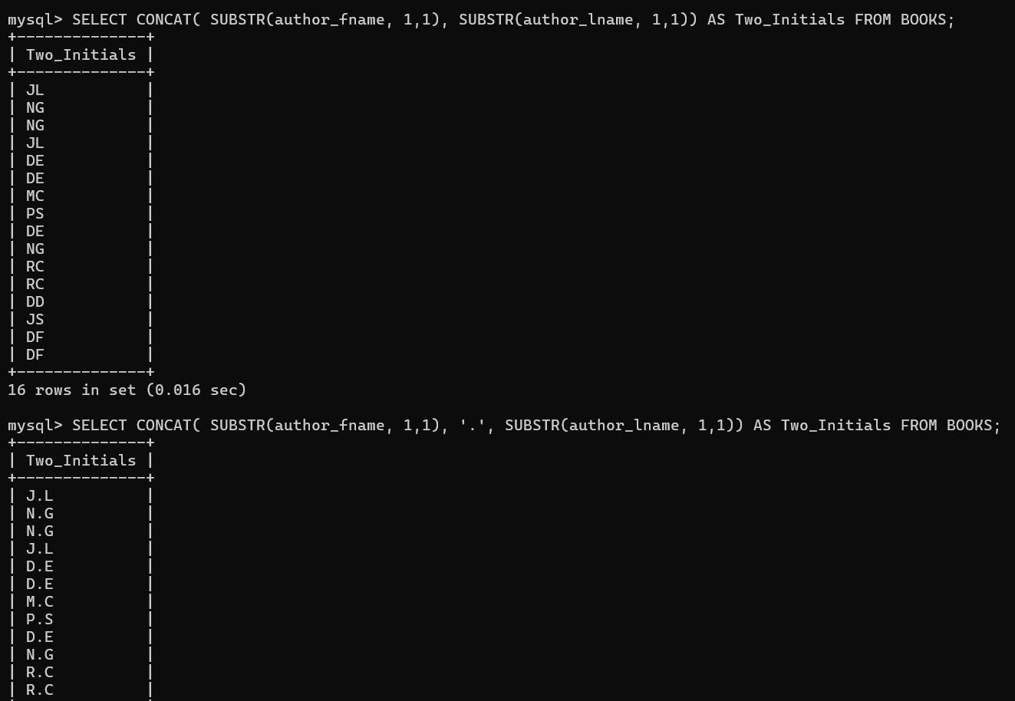

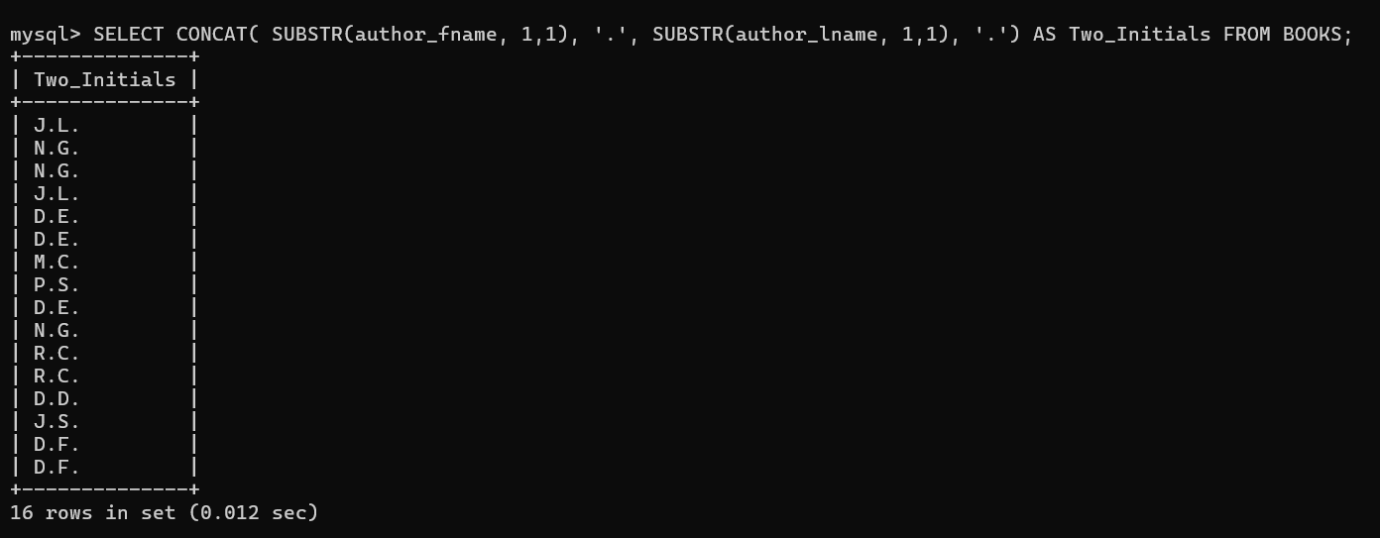

5. Replace

Replace parts of strings.

- SELECT REPLACE('Hello World', 'Hell', '%$#@');

- SELECT REPLACE('Hello World', 'l', '7');

- SELECT REPLACE('Hello World', 'o', '0');

- SELECT REPLACE('HellO World', 'o', '*');

- SELECT
- REPLACE('cheese bread coffee milk', ' ', ' and ');

- SELECT REPLACE(title, 'e ', '3') FROM books;

- SELECT REPLACE(title, ' ', '-') FROM books;

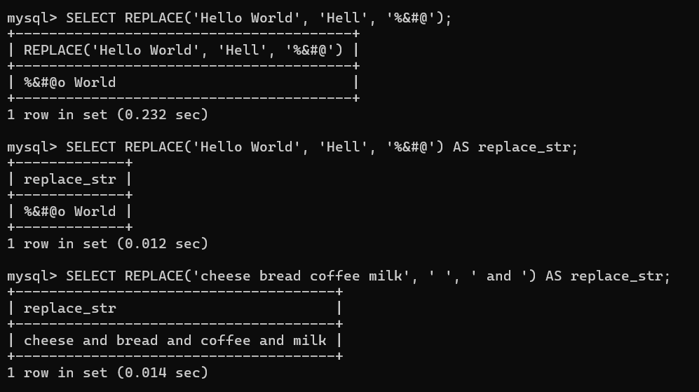

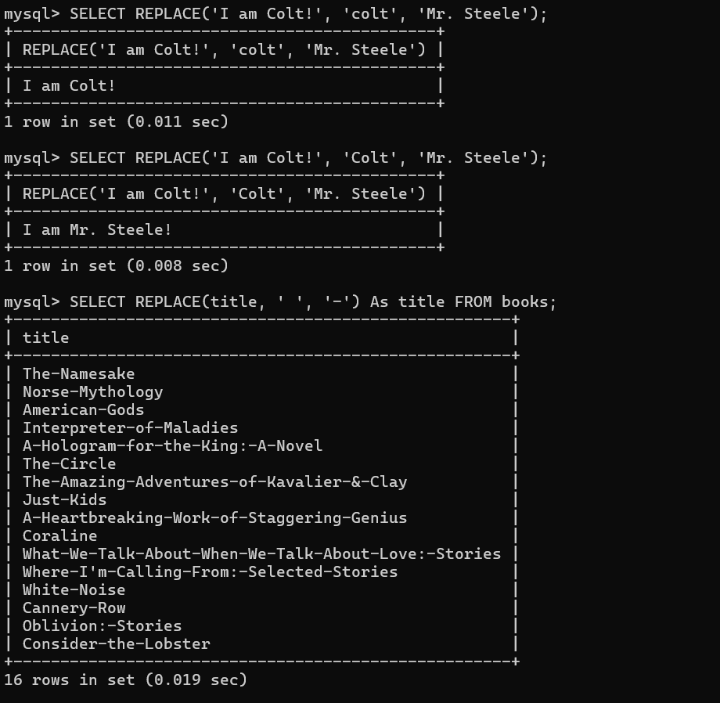

6. Reverse

- SELECT REVERSE('Hello World');

- SELECT REVERSE('meow meow');

- SELECT REVERSE(author_fname) FROM books;

- SELECT CONCAT('woof', REVERSE('woof'));

- SELECT CONCAT(author_fname, REVERSE(author_fname)) FROM books;

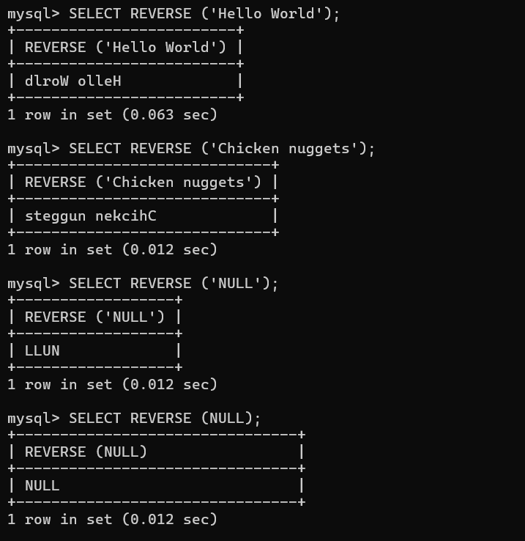

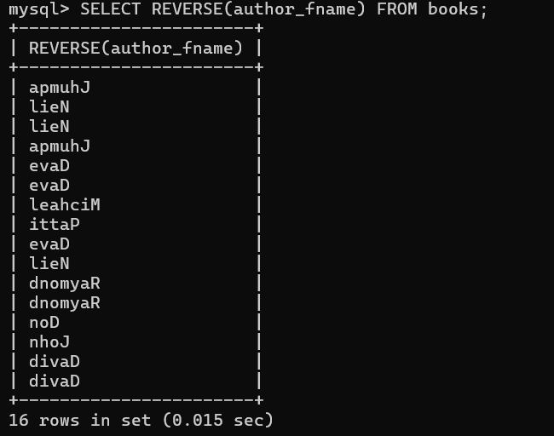

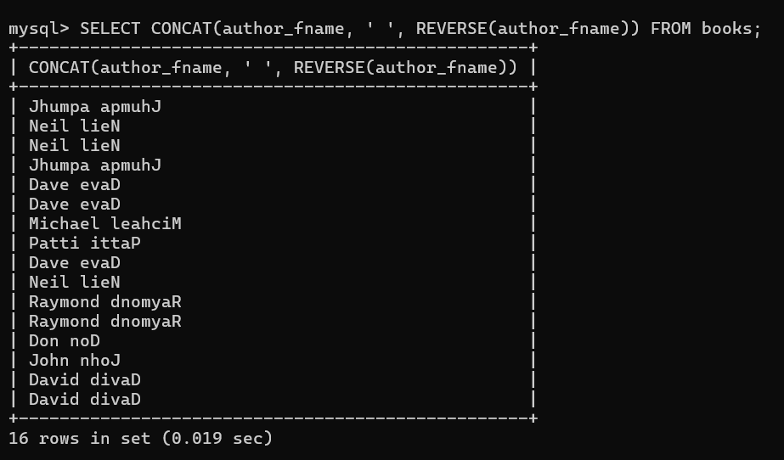

7. CHAR LENGTH

- SELECT CHAR_LENGTH('Hello World');

- SELECT CHAR_LENGTH(title) as length, title FROM books;

- SELECT author_lname, CHAR_LENGTH(author_lname) AS 'length' FROM books;

- SELECT CONCAT(author_lname, ' is ', CHAR_LENGTH(author_lname), ' characters long') FROM books;

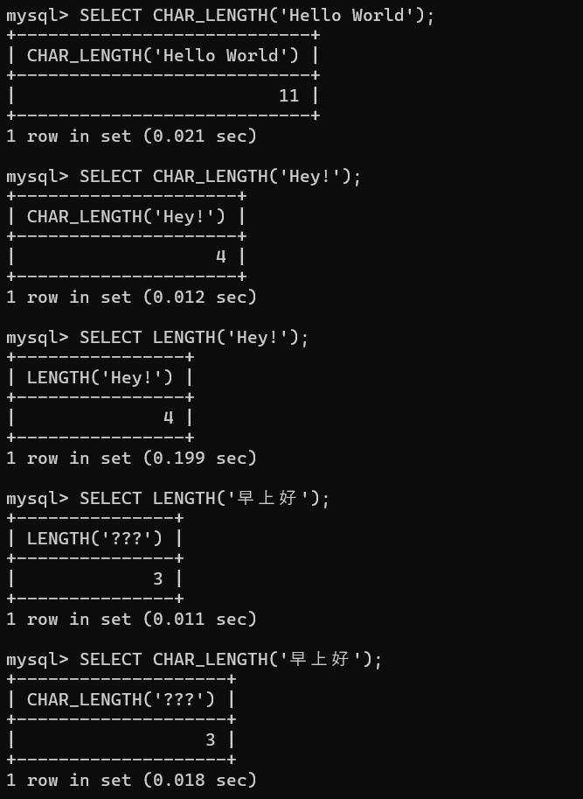
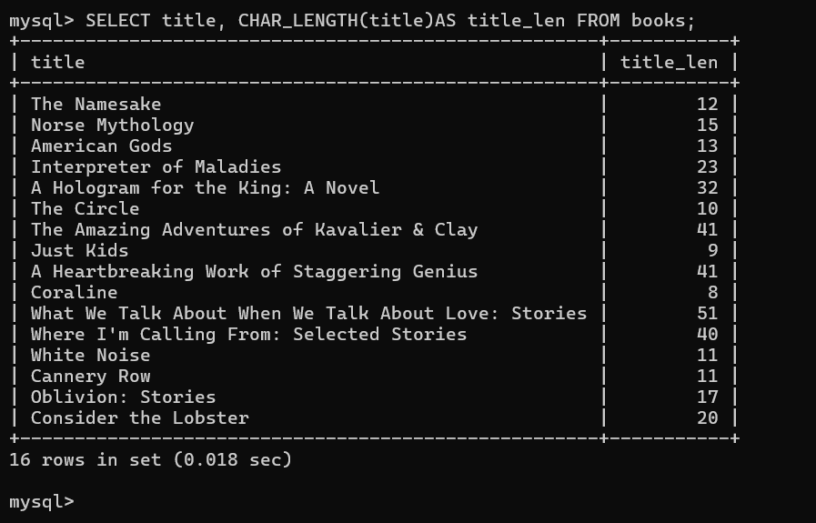

8. Upper and lower

Change a string’s case

- SELECT UPPER('Hello World');

- SELECT LOWER('Hello World');

- SELECT UPPER(title) FROM books;

- SELECT CONCAT('MY FAVORITE BOOK IS ', UPPER(title)) FROM books;

- SELECT CONCAT('MY FAVORITE BOOK IS ', LOWER(title)) FROM books;

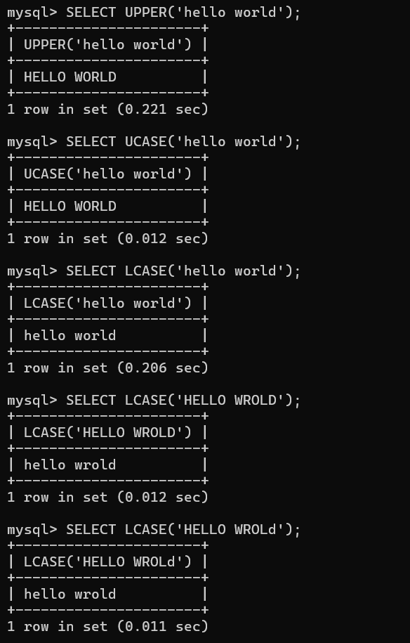
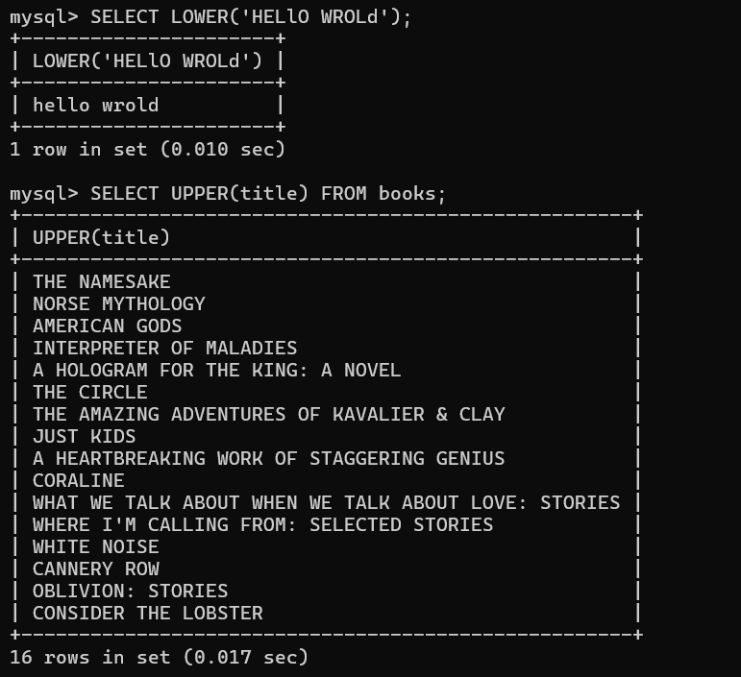

Exercise

- SELECT REVERSE(UPPER('Why does my cat look at me with such hatred?'));

- SELECT REPLACE(title, ' ', '->') AS title FROM books;

- SELECT
- author_lname AS forwards, REVERSE(author_lname) AS backwards
- FROM
- books;

- SELECT UPPER(CONCAT(author_fname, ' ', author_lname)) AS 'full name in caps' FROM books;

- SELECT CONCAT(title, ' was released in ', released_year) AS blurb FROM books;

- SELECT title, CHAR_LENGTH(title) AS character_count FROM books;

- SELECT
- CONCAT(SUBSTR(title, 1, 10), '...') AS short_title,
- CONCAT(author_lname, ',', author_fname) AS author,
- CONCAT(stock_quantity, ' in stock') AS quantity
- FROM
- Books;

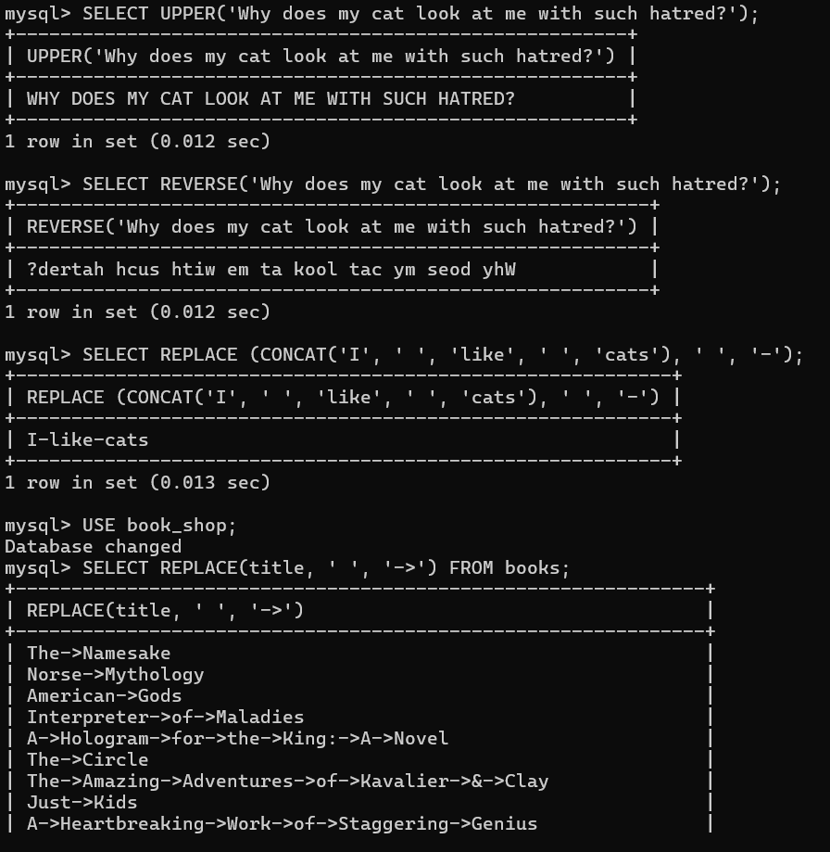

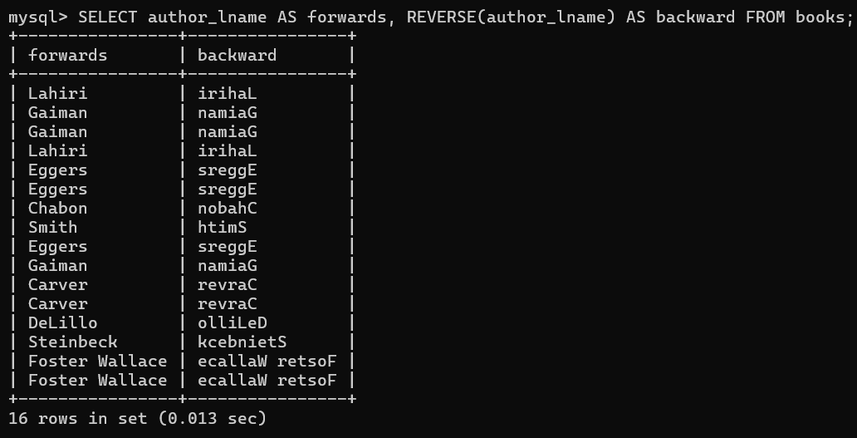

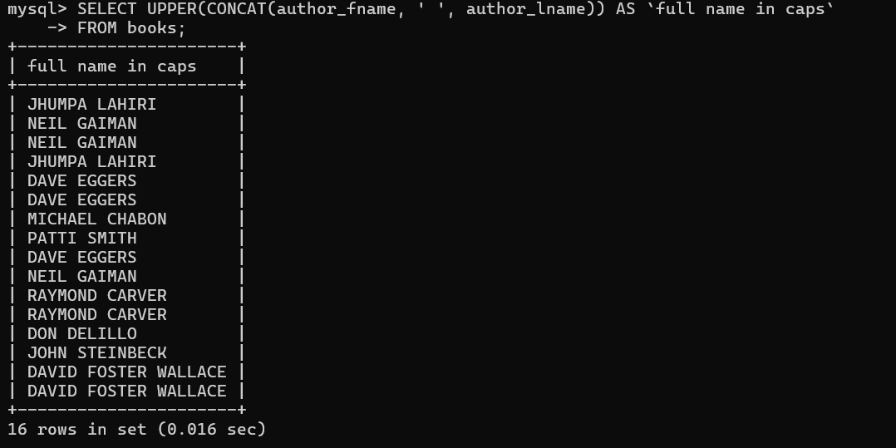

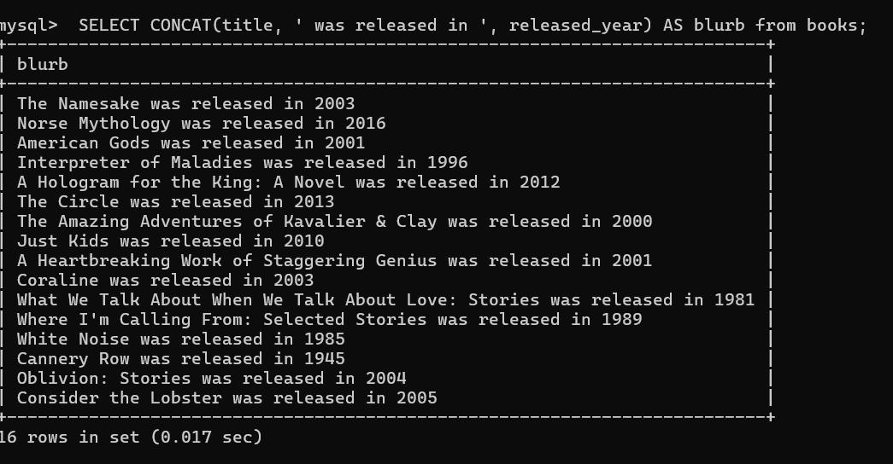

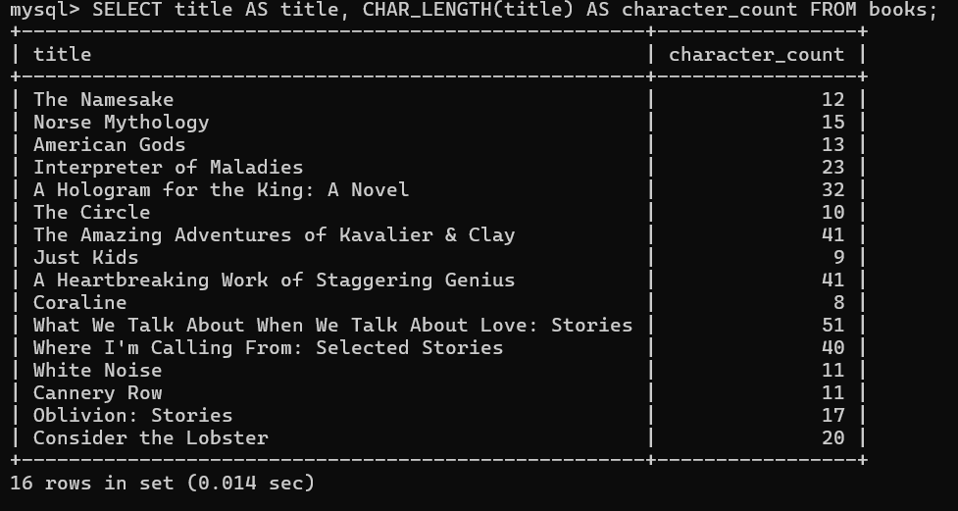

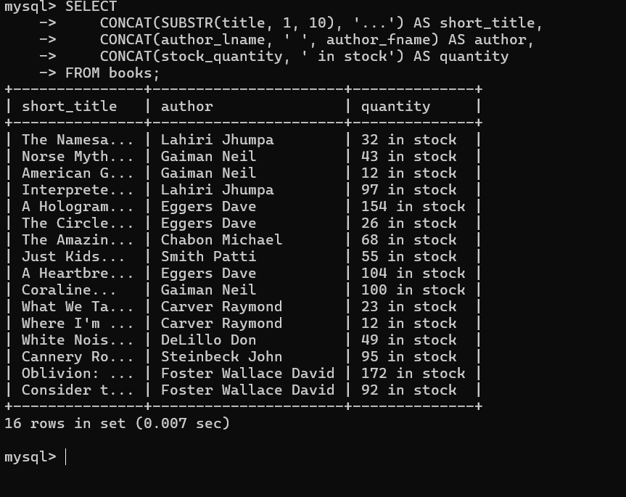

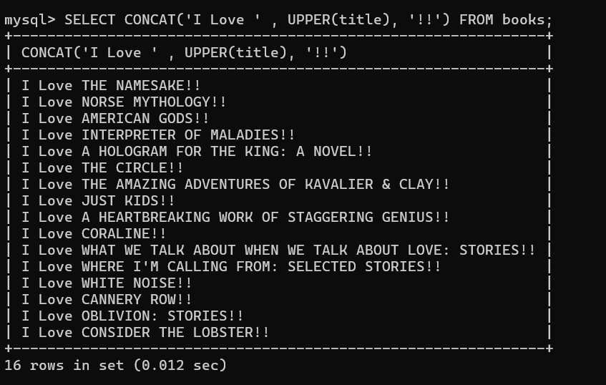

9. String functions:

- SELECT INSERT('Hello Bobby', 6, 0, 'There');

- SELECT LEFT('omghahalol!', 3);

- SELECT RIGHT('omghahalol!', 4);

- SELECT REPEAT('ha', 4);

- SELECT TRIM(' pickle ');

Insert

Insert character write start number and end number in the cmd.

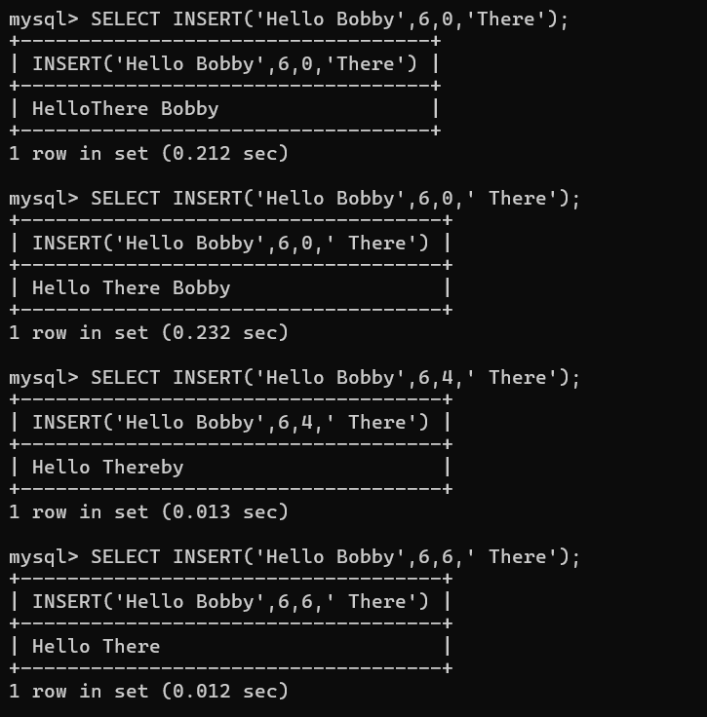

LEFT function

Take the character from left using the numbers.

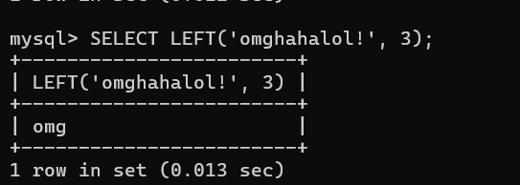

Right Function

Take the character from right using the numbers.

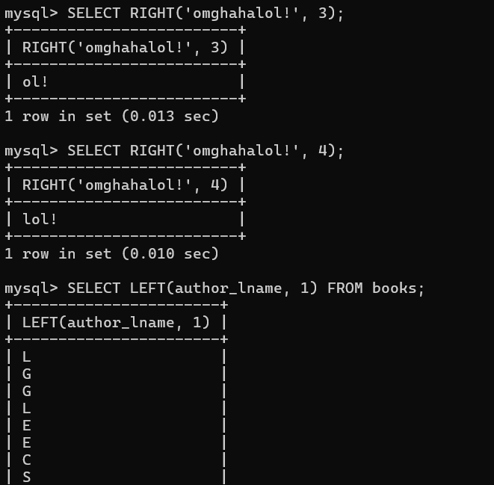

Repeat

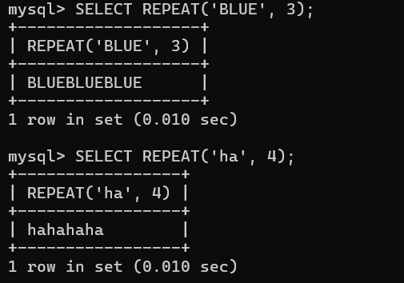

TRIM Function:

Remove spaces, begging space and ending space.

